***User Table***

1. **POST 🡪 Adding a user to the user table *http://localhost:7777/user***

***{***

***"userId": 2,***

***"firstName": "Smriti",***

***"lastName": "Shettigar",***

***"email": "smriti@gmail.com",***

***"mobile": "1234567899"***

***}***

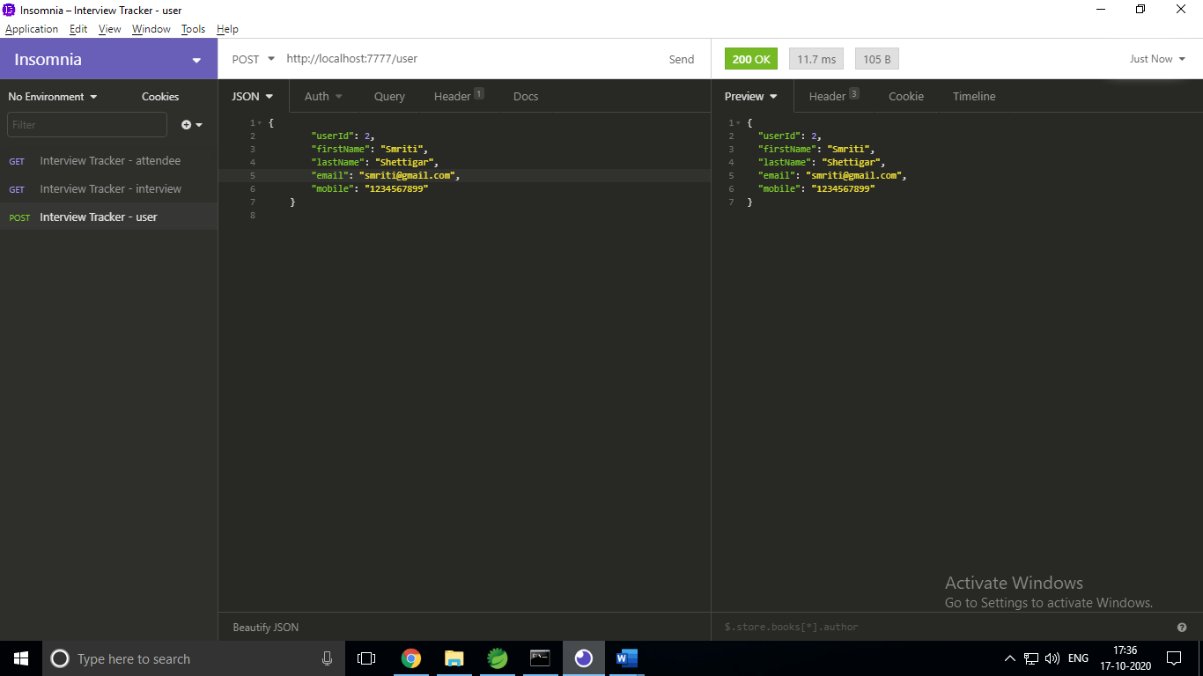

1. **GET 🡪 Retrieving users from the user table *http://localhost:7777/user***

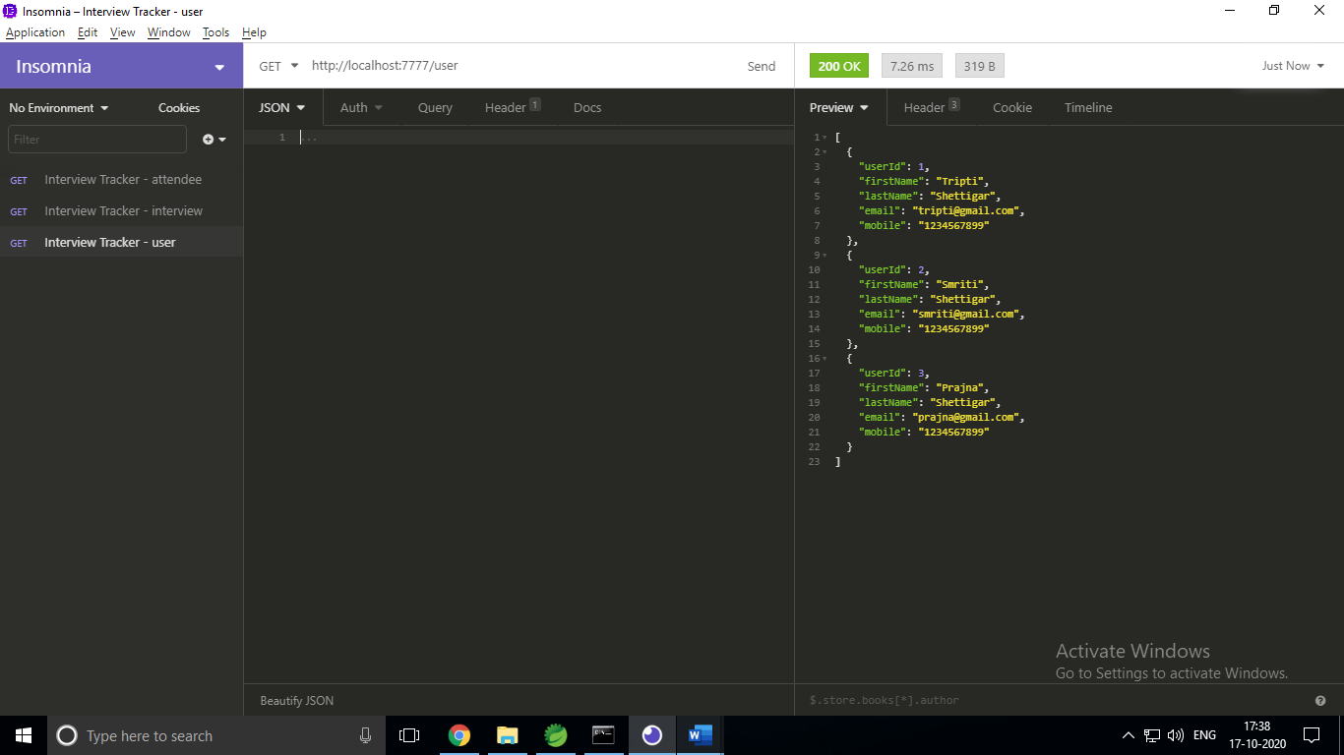

1. **DELETE 🡪 Deleting a user from the user table*****http://localhost:7777/user/4***

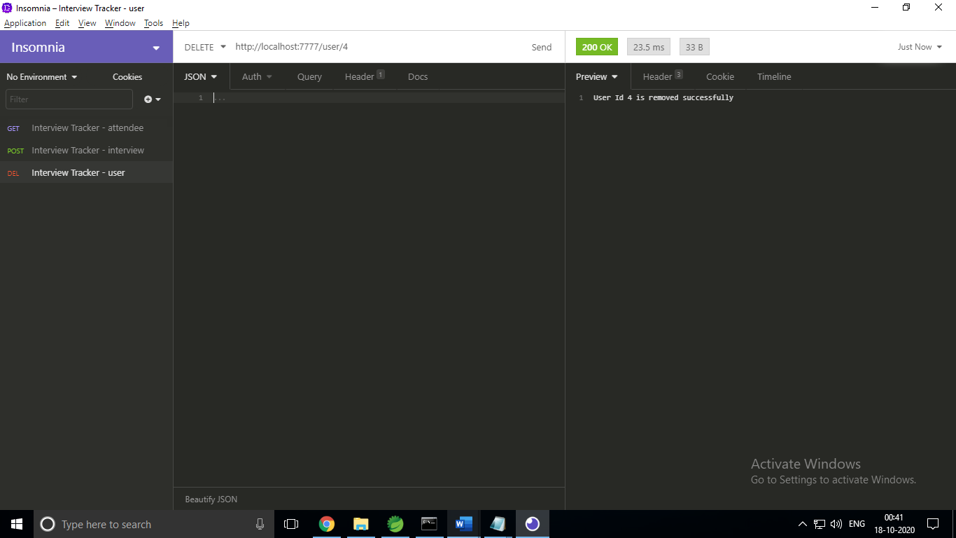

***Interview Table***

1. **POST 🡪 Adding an interview to the interview table *http://localhost:7777/interview***

***{***

***"interviewId": 102,***

***"interviewerName": "Mark Ronson",***

***"interviewName": "Project Manager",***

***"usersSkills": "LMNOPQ",***

***"time": "11:30:00",***

***"date": "2020-10-19",***

***"interviewStatus": "Yet to begin",***

***"remarks": "Looking for exp of around 4-5 years"***

***}***

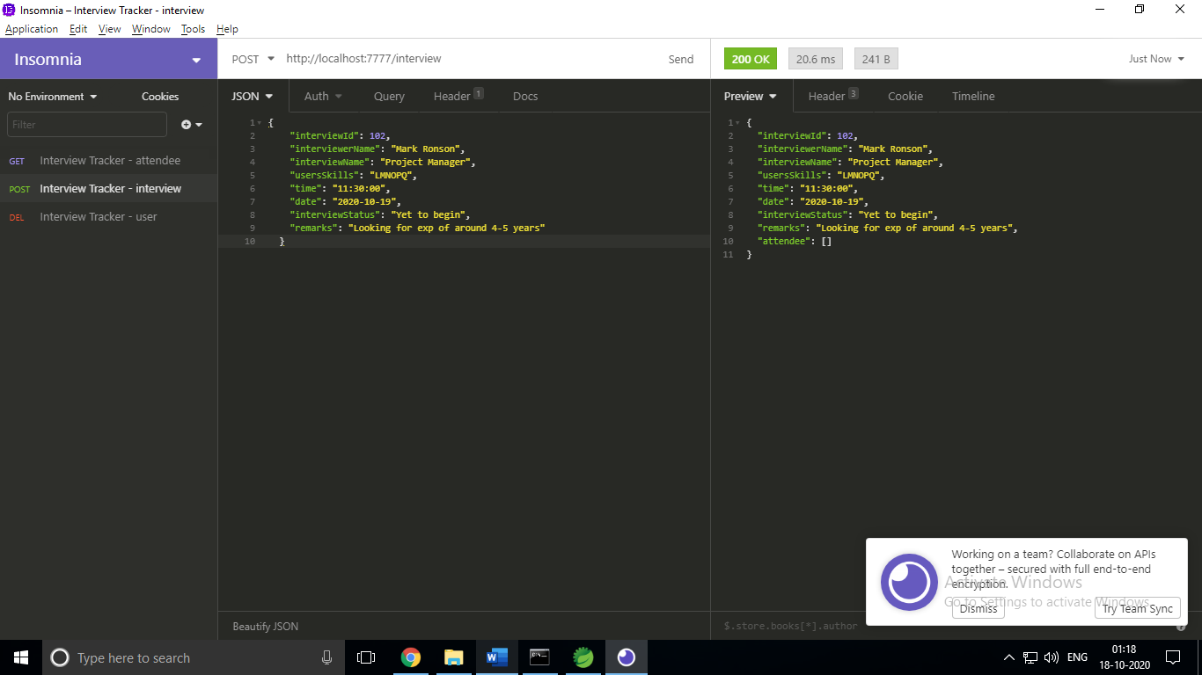

1. **GET 🡪 Retrieving all interviews from the interview table *http://localhost:7777/interview***

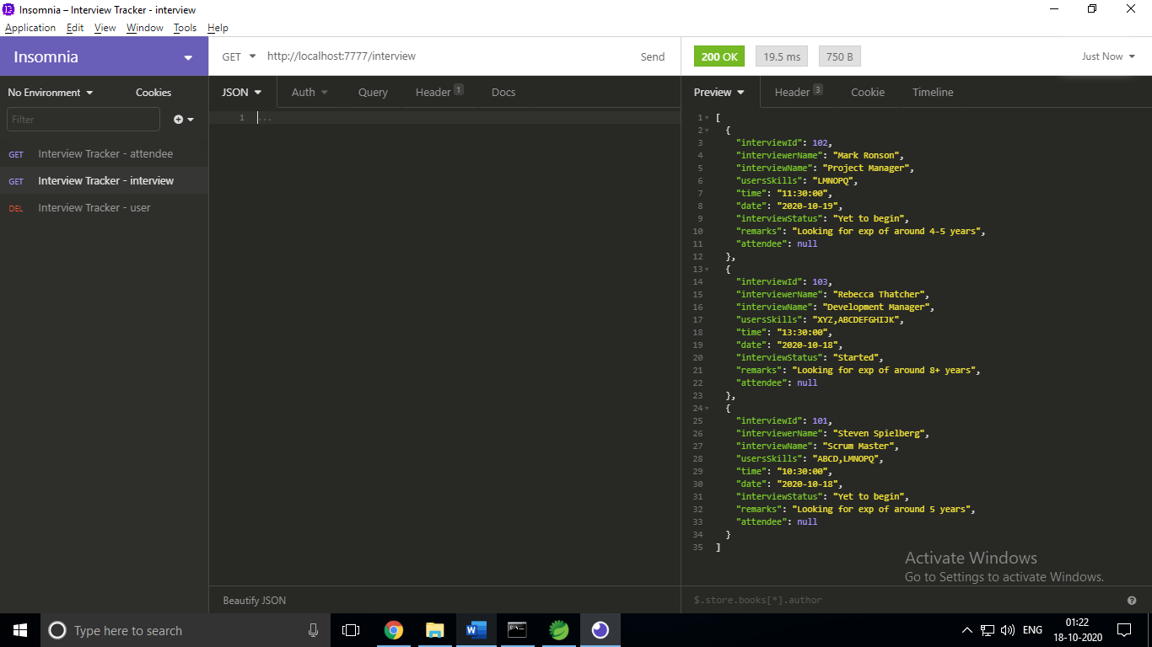

1. **GET🡪 Retrieve interview using interviewer Name *http://localhost:7777/interview/showByName/Mark Ronson***

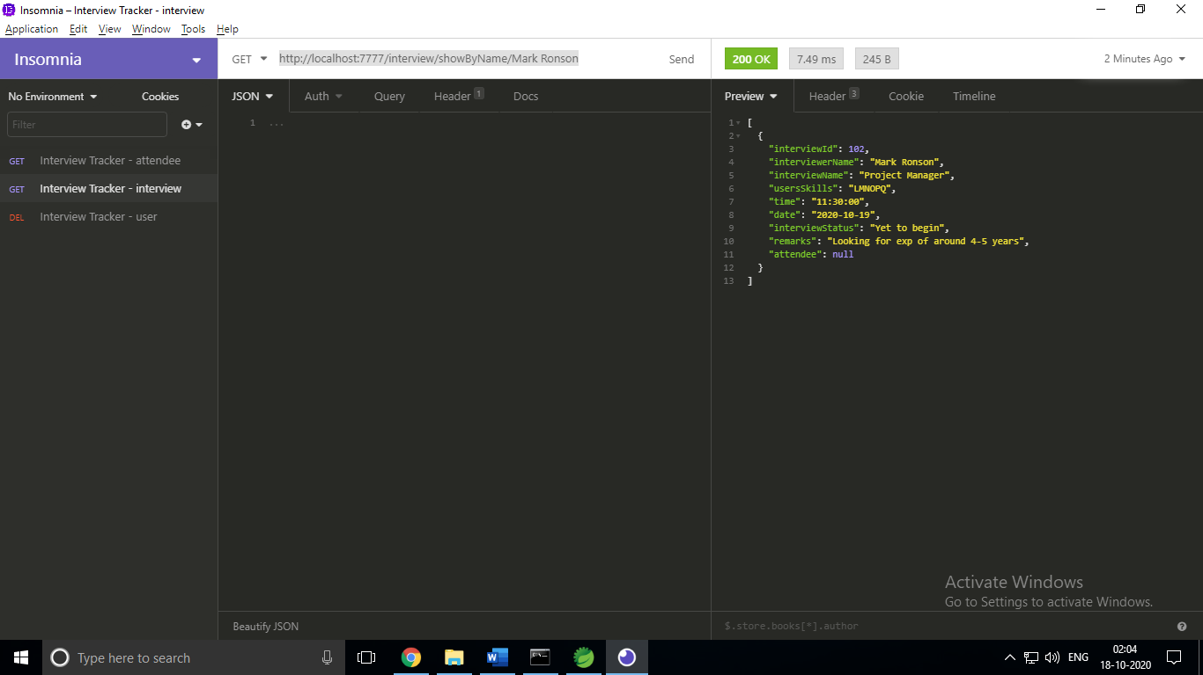

1. **GET🡪 Retrieve interview using interview Name**

***http://localhost:7777/interview/showByInterview/Scrum Master***

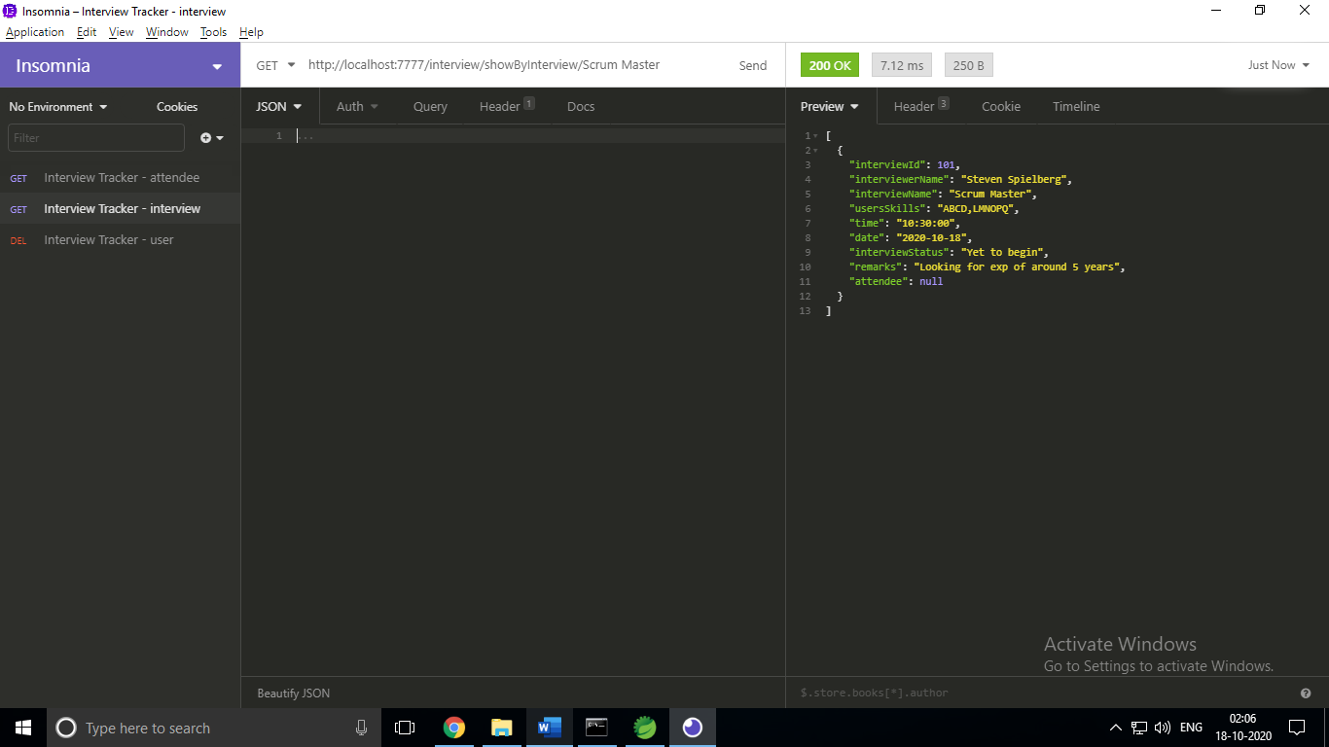

1. **GET 🡪 Retrieving number of interviews added in the interview table**

***http://localhost:7777/interview/getCount***

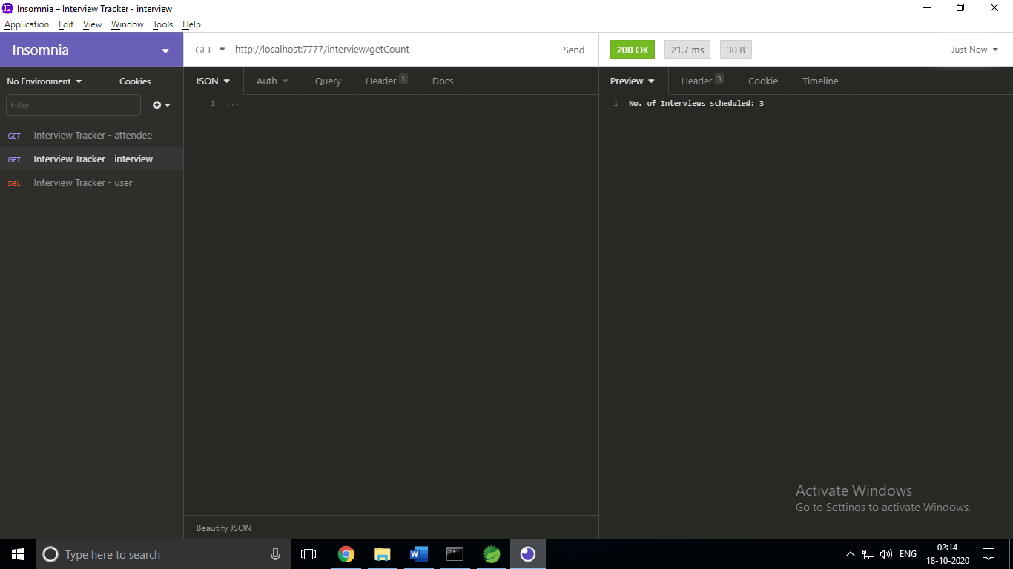

1. **PUT 🡪 Updating interviewStatus in the interview table**

***http://localhost:7777/interview/103/In-Progress***

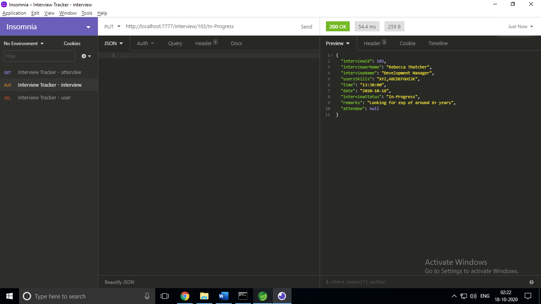

1. **DELETE 🡪 Deleting an interview from the interview table**

***http://localhost:7777/interview/103***

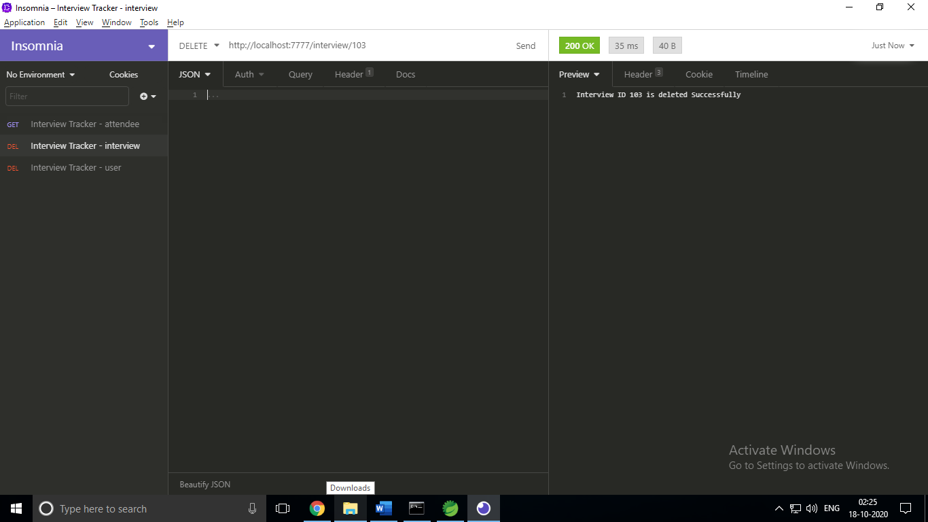

1. **POST 🡪 Adding an attendee to the interview table**

***http://localhost:7777/interview/addAttendee***

***{***

***“interviewId” : 103,***

***“userId” : 1***

***}***

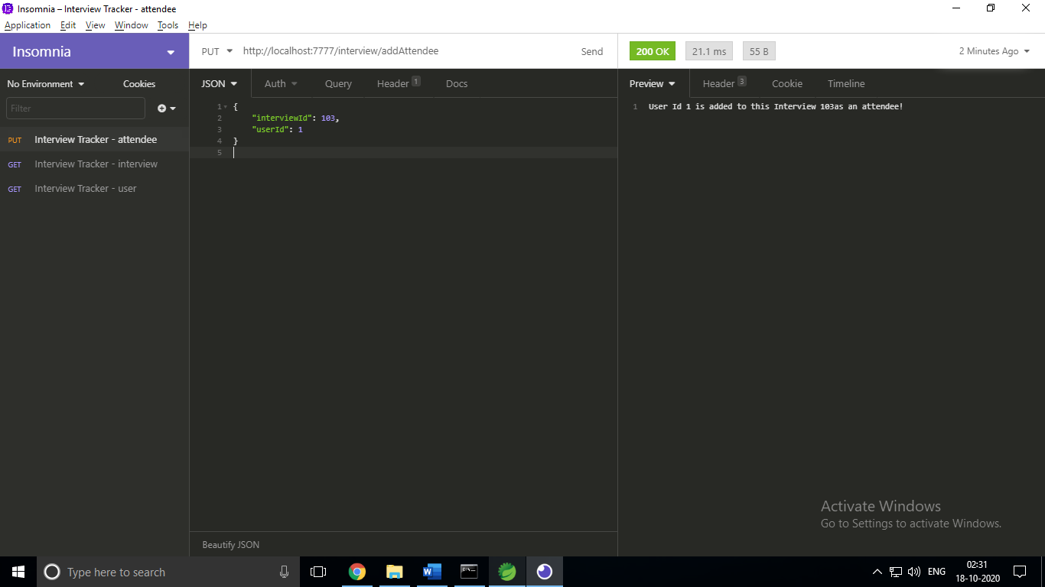

1. **GET 🡪 Retrieving all attendees for an interview from the attendee table**

***http://localhost:7777/interview/showAttendees/103***

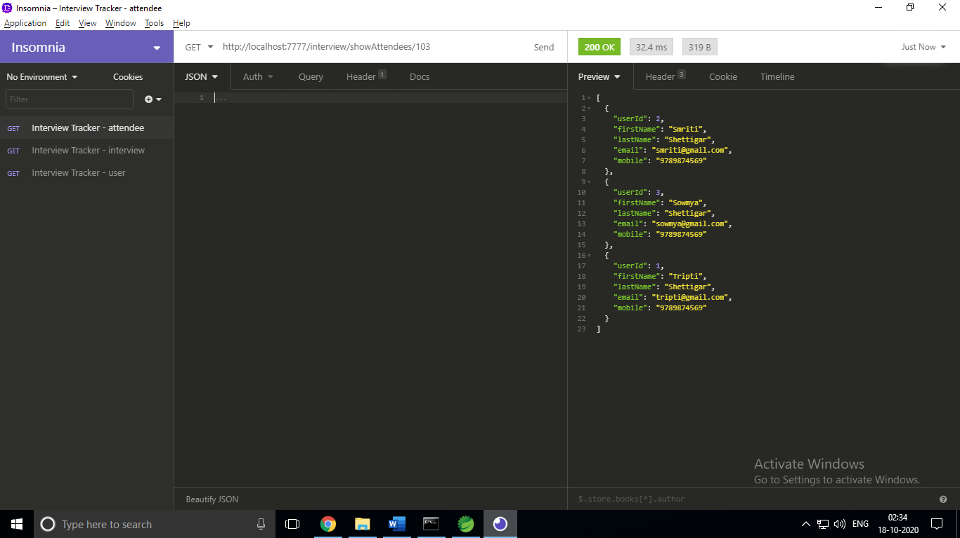

***Exceptions/Validations:***

1. **POST🡪 Adding user with existing userId *http://localhost:7777/user***

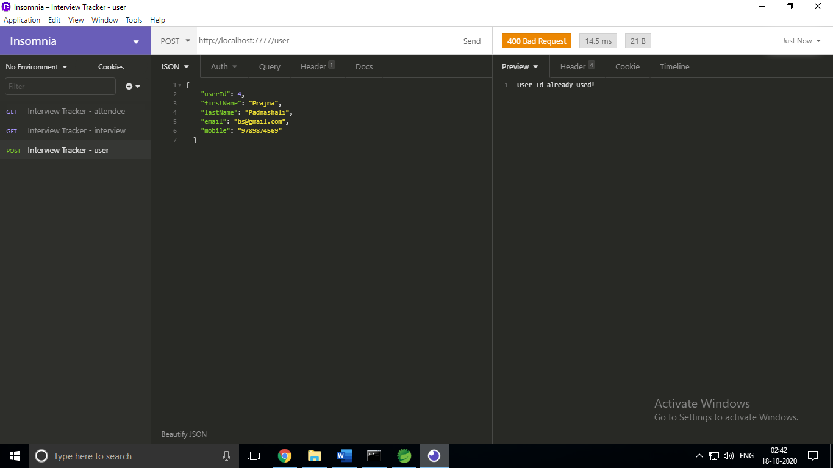

1. **POST**🡪 **Adding user with incorrect details *http://localhost:7777/user***

***{***

***"userId": 5,***

***"firstName": "P",***

***"lastName": "Pad",***

***"email": "bs@",***

***"mobile": "45"***

***}***

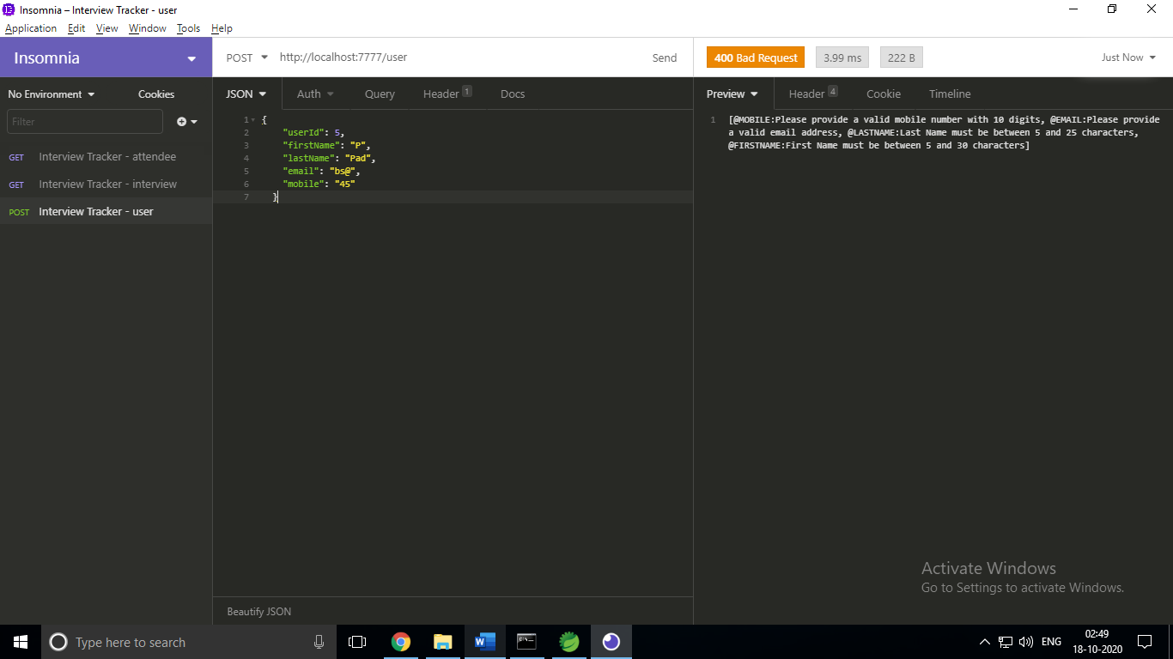

1. **DELETE🡪 Deleting user not found in the user table *http://localhost:7777/user/6***

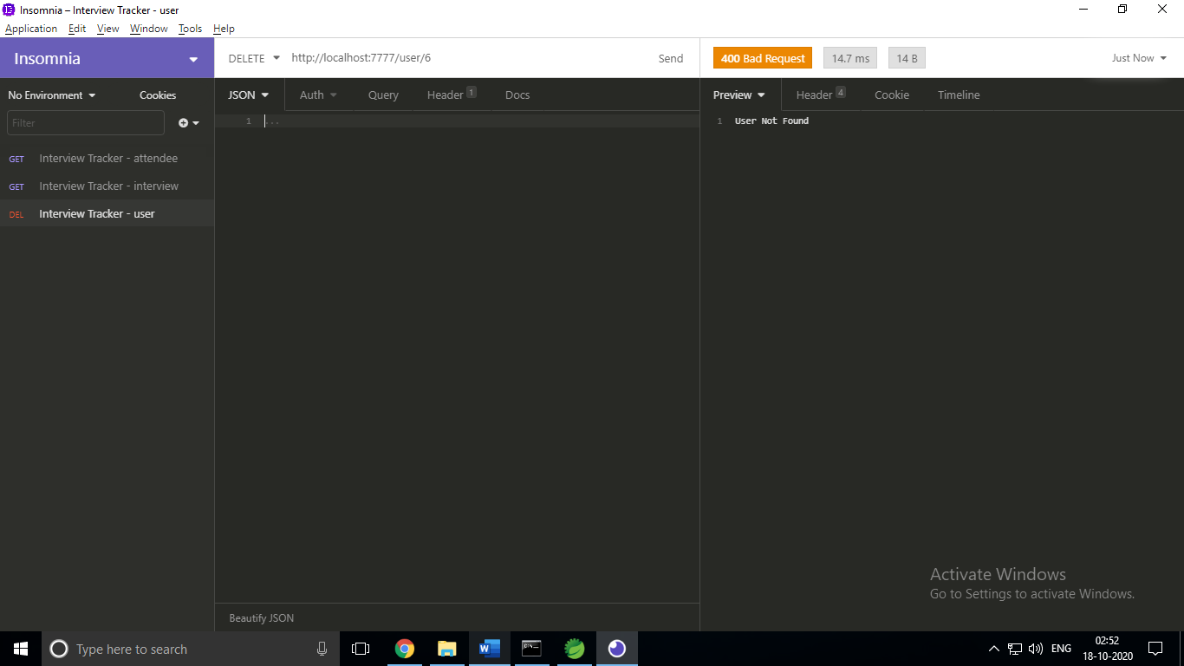

1. **POST🡪 Adding interview with existing interviewID** [***http://localhost:7777/interview***](http://localhost:7777/interview)

***{***

***"interviewId": 104,***

***"interviewerName": "Steven Spielberg",***

***"interviewName": "QA Specialist",***

***"usersSkills": "ABCD,LMNOPQ",***

***"time": "10:30:00",***

***"date": "2020-10-18",***

***"interviewStatus": "Yet to begin",***

***"remarks": "Looking for exp of around 5 years",***

***"attendee": null***

***}***

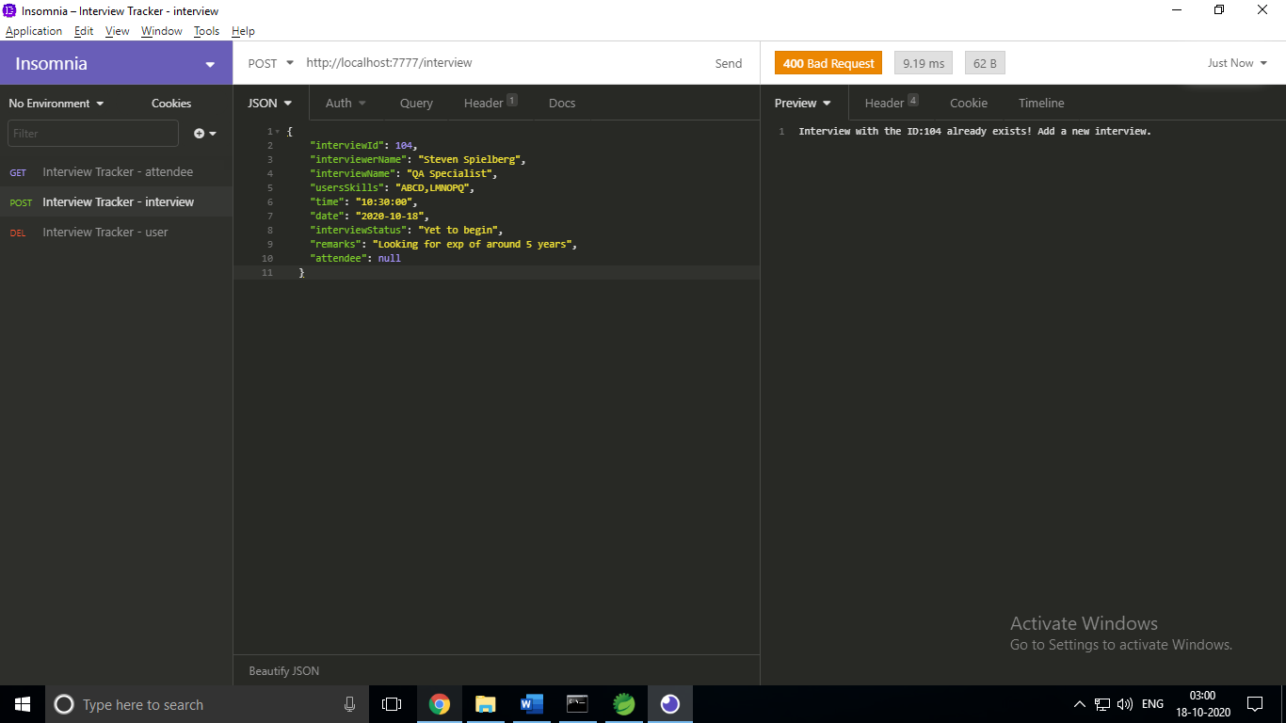

1. **POST**🡪 **Adding interview with incorrect details *http://localhost:7777/ interview***

***{***

***"interviewId": 104,***

***"interviewerName": "Tim",***

***"interviewName": "QA",***

***"usersSkills": "XY",***

***"time": "13:30:00",***

***"date": "2020-10-18",***

***"interviewStatus": "Started",***

***"remarks": "Looking for exp of around 8+ years",***

***"attendee": null***

***}***

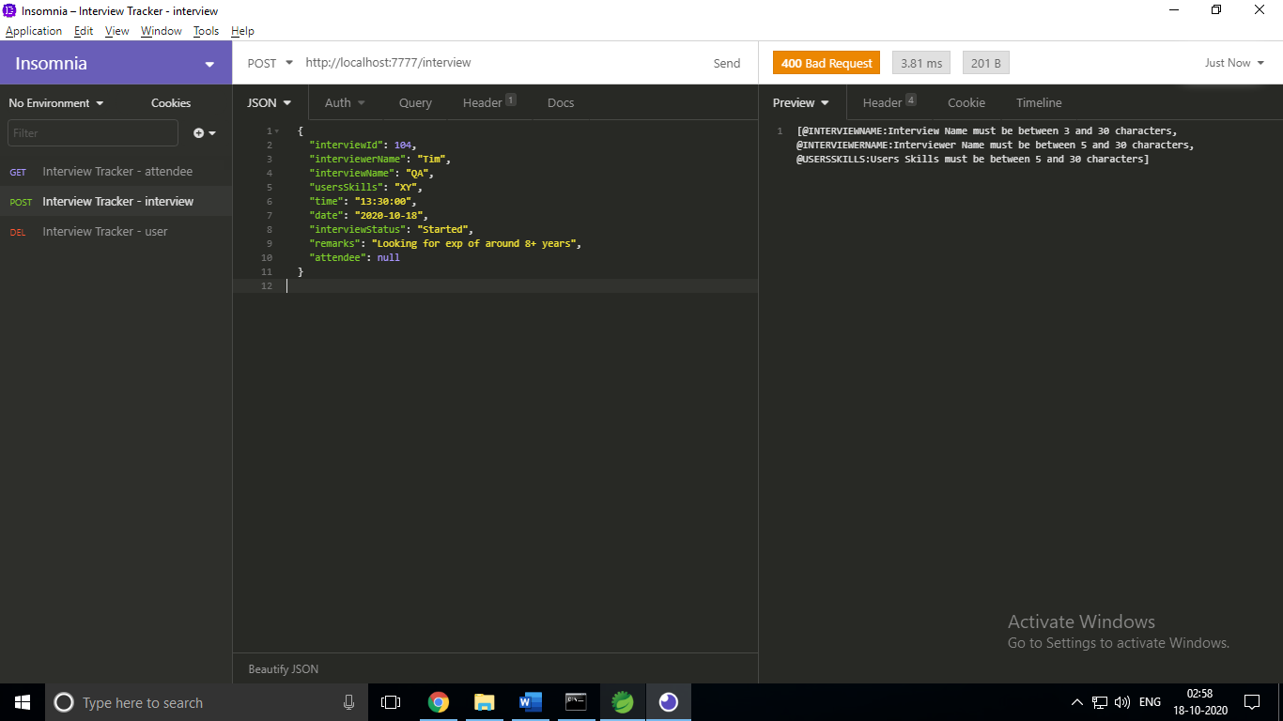

1. **DELETE🡪 Deleting interview not found in the interview table *http://localhost:7777/ interview/105***

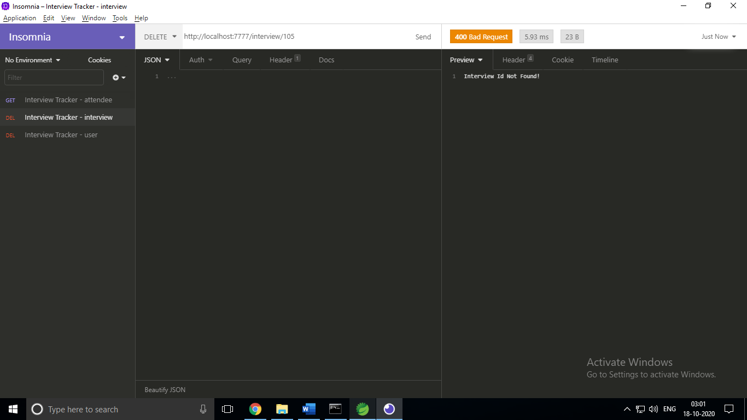

1. **PUT 🡪 RE-adding the user to the same interview** [***http://localhost:7777/interview/addAttendee***](http://localhost:7777/interview/addAttendee)

***{***

***"interviewId" : 103,***

***"userId" : 3***

***}***

